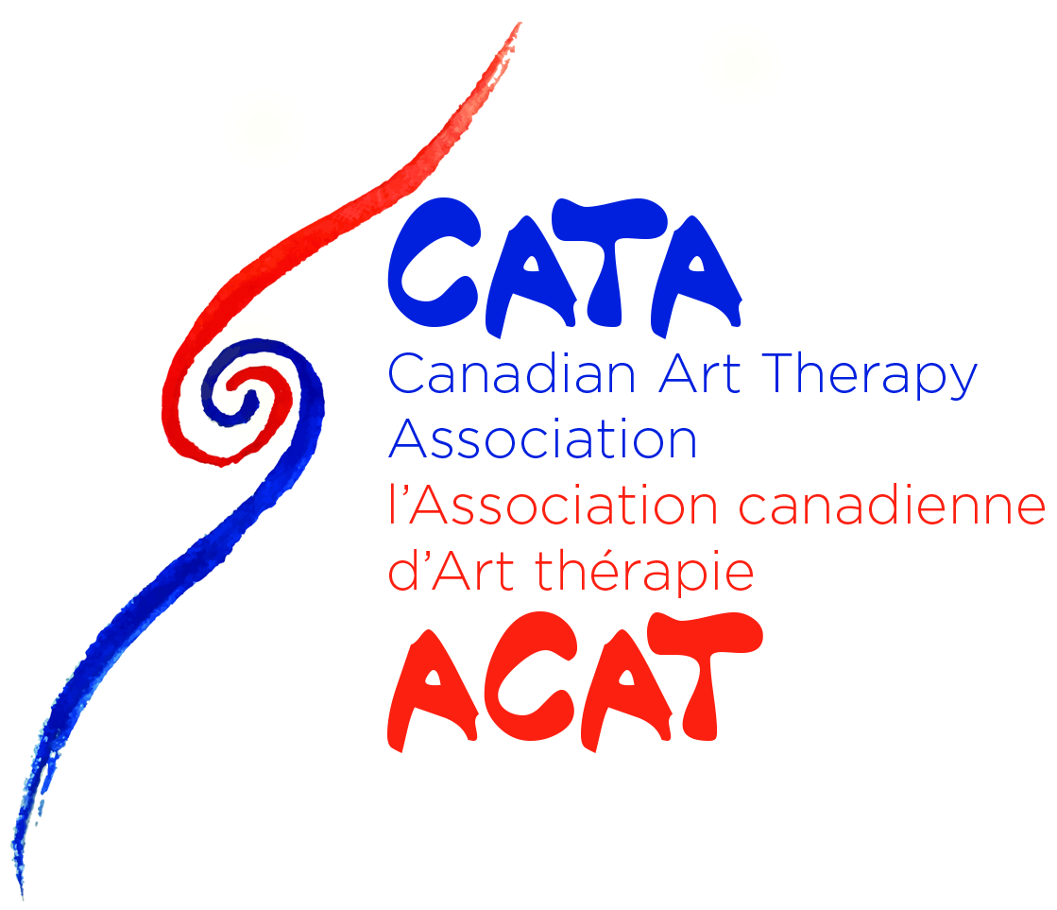- ETHICS COMPLAINT FORM -

CONFIDENTIAL

CATA-ACAT Use Only:

Date Received:_____________________________  Member ID#: ______________________________  Category: _________________________________  Entered into database: _______________________ | Acknowledgement letter sent: _________________  Date Reviewed: ____________________________  Complaint #: ______________________________  Review Committee Lead: _____________________

This form is supplied by the Canadian Art Therapy Association/L’Association Canadienne d’Art Therapie (CATA-ACAT) to individuals, groups, or organizations (‘complainants’) who want to submit an ethics Complaint regarding the conduct of a CATA-ACAT member or of an individual who is not a CATA-ACAT member but who is (1) considering registering or applying to be one, (2) serves CATA-ACAT in a volunteer capacity, (3) is sub contracted by CATA-ACAT to assist in conferences, workshops, or other group event.
In order to commence the ethics complaint process, please complete this form and mail to:
Ethics Review Committee
Canadian Art Therapy Association
L’Association Canadienne d’Art Therapie
PO BOX 658, Stn Main
Parksville, BC V9P 2G7

This form may also be e-mailed directly to

CATA-ACAT Ethics Inbox: ethics@canadianarttherapy.org
CATA-ACAT Office: admin@canadianarttherapy.org

2.0 Responsibilities and notice of Confidentiality

While this is a confidential process, the person names as a respondent in this complaint may be provided with a copy of this complaint; further, CATA-ACAT staff and agents, and witnesses may be made aware of the existence of this complaint as part of the ethics review process. Complaints will not be considered complete until the administration receives all required documentation, which includes: 1) the completed complaint form, 2) all applicable supplemental information required to establish a breach of the code of conduct or professional ethical responsibilities, 3) all and any other documentation requested in writing (including e-mail) by CATA-ACAT administration, review committee, or board.

CATA-ACAT provides this forum for professional complaints. No compensation will be provided by CATA-ACAT as a result of disciplinary action or as a consequence of a violation of professional ethics.

The Ethics Review Committee will not review anonymous and/or trivial complaints. Furthermore, please ensure you have all relevant supporting documentation and that the complaint is not based on hearsay.

3.0 Complainant’s Information

Complaint’s full name: _______________________________________________
Complaint’s Address: _______________________________________________
_______________________________________________
Phone: +1 (____) _____ ______
Member of CATA-ACAT? Yes ___ No___
Email Address: _______________________________________________

4.0 Respondent’s Information

*Respondent is the person against whom the complaint is being filed.
**Please fill as much information as available

Respondent’s full name: _______________________________________________
Respondent’s Address: _______________________________________________
_______________________________________________
Respondent’s Phone: +1 (____) _____ ______
Member of CATA-ACAT? Yes ___ No___
Email Address: _______________________________________________
Note: You must file a separate form for each individual you wish to file a complaint against. This form maybe used for multiple respondent’s if it pertains to a unique incident.

5.0 Nature of Complaint

Please check all that apply. If none apply, please check ‘Other’ and provide a description.

Sexual contact with a client ___
Administrative/Recordkeeping ___
Failure to release patient records ___
Impairment/medical condition ___
Advertising violation ___
Patient abandonment/neglect ___
Confidentiality ___
Conflict of Interest ___
Other than listed above (specify): ________________________________________
_________________________________________________________________________

6.0 Complainant’s Statement

Please provide a statement of what you consider to be the essential facts involved in the alleged ethics violation. Please include specifics (time, date, context, etc.) When possible, please specify what sections of the Code of Conduct the member has violated.

_________________________________________________________________________________________________________________________________________________________________________________________________________________________________________________________________________________________________________________________________________________________________________________________________________________________________________________________________________________________________________________________________________________________________________

7.0 Other Complaints Filed to date

Please list any actions taken or contemplated that are directed at the same or related complaints. For example, the complainant should identify any matters filed with Provincial bodies, Educational institutes, regulatory boards, courts, or other judicial forms, professional organizations, and employers that relate to the issues raised in this Complaint. Please note that CATA-ACAT review board can not consider complaints against a respondent when existing civil, criminal, and regulatory proceedings are ongoing against the respondent.

_________________________________________________________________________________________________________________________________________________________________________________________________________________________________________________________________________________________________________________________________________________________________________________________________________________________________________________________________________________________________________________________________________________________________________

8.0 Other Persons of interest

Please list all person(s) you believe may have knowledge of the matters asserted in this complaint. A brief description of what their knowledge of the matter may be should be included.

_________________________________________________________________________________________________________________________________________________________________________________________________________________________________________________________________________________________________________________________________________________________________________________________________________________________________________________________________________________________________________________________________________________________________________

9.0 Steps you have taken thus far

Please provide a brief synopsis of all the steps (if any) you have taken to attempt to resolve the complaint before making this official ethics complaint. If you have not made any attempts, please explain your concerns.

_________________________________________________________________________________________________________________________________________________________________________________________________________________________________________________________________________________________________________________________________________________________________________________________________________________________________________________________________________________________________________________________________________________________________________

10.0 Documents

Please list documents you are attaching to this form. Documents may include and are not limited to letters, e-mails, memos, certificates, screenshots, receipts, photos, and other correspondence.

- ____________________________________________
- ____________________________________________
- ____________________________________________
- ____________________________________________
- ____________________________________________

11.0 Waiver, Authorization, and Certification Statements

I hereby waive any privilege which I may have pertaining to the matter raised in this official ethics complaint, so that the Respondent may adequately respond to the Complaint. This waiver also allows the CATA-ACAT Ethics Committee to provide confidential information to the those individuals who, in the sole discretion of the Committee, its staff, or legal counsel, it may be necessary to contact in order to conduct a full and fair investigation of the Complaint; and

I authorize the release of the information contained in the Complaint to the President of CATA-ACAT, the professional staff of CATA-ACAT, legal counsel for CATA-ACAT, and members of the CATA-ACAT Ethics Committee, and those individuals who in the sole discretion of the Committee, its staff, or legal counsel, it may be necessary to contact in order to conduct a full and fair investigation of the Complaint, or to carry out any resulting therapy or supervision related to possible discipline in the case; and

I understand that information or documentation concerning this Complaint obtained in the course of a review investigation is confidential and shall not be disclosed or produced except where required legally by a jurisdiction in Canada; and

I hereby authorise the use of my name in the investigation of the Complaint by the President of CATA-ACAT, the professional staff of CATA-ACAT, legal counsel for CATA-ACAT, and the members of the CATA-ACAT Ethics Committee.

I hereby give the member(s) against whom I am making this complaint permission to give the CATA-ACAT Ethics Committee any confidential information regarding me, including any records of our interactions, and to answer all questions the Committee may have concerning such information.

I hereby give the CATA-ACAT Ethics Committee permission to send to the member(s) against whom I am making this complaint, copies of any materials submitted by me or on my behalf concerning this complaint.

I hereby waive any right to subpoena from CATA-ACAT or its agents, for the purposes of private civil litigation, any documents or information concerning this matter.

Signature: _____________________________________________ Date: _________________

